**Final submission shall include the following:**

1. Complete Source Code with proper documentation

2. Database (you can export the MySQL database to a file and include that file using “outfile” command)

3. A detailed report describing the work done by team and each member right from the starting of the project. It may also include new concepts learned and challenges faced.

4. Error correction schemes’ (three of them) detailed explanation along with example. Example shall be using the data you collected from Planetlab.

5. Data representation (see below): If you think you can add better graphs to enhance the visualization the behavior of the data then make sure to include more figures (this extra step may also demonstrate that you understand the problem and data behavior correctly).

Data presentation for CS570 Project:

1. CDF of delay vs distance:

X-axis: distance

Y-axis: CDF of different delay ranges (0-100, 101-200, 201-300, 301-400, 401-500)

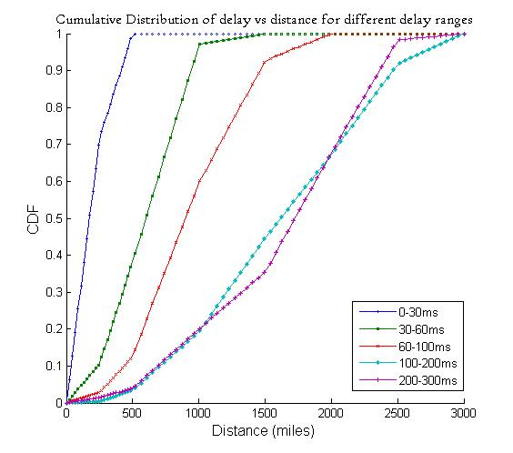

2. Distribution of measurements for any 4 nodes in your planetlab set.

X-axis: φ (z)

Y-axis: z scores for standard normal distribution

F:\IGOD\pdf-distribution.tif

3. Q-Q plot for any 4 planetlab nodes:

F:\IGOD\qqplot.tif

4. CDF plot for any 10 planetlab nodes.

X-axis: CDF

Y-axis: Error distance observed at this planetlab node in different readings for source as a node you select and destination as all other nodes.

(Error distance = [|Actual_Distance – (DDR * Delay)|], no error correction

Do not forget to mention how you calculated DDR and why? (is it mean/median/mode…?)

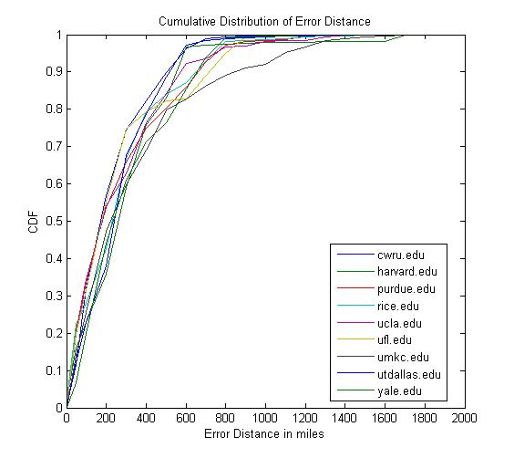

5. Three more graphs same as 4 but this time with three different error correction schemes.

6. Same as 4 but this time for different source and destination pairs.

7. Select a node, n, which was active in most of your readings. Then select any 5 different Lat/Lon pair (LLi) where 0 < i <= 5. A zone is area surrounding a LL.

Plot the CDF of error distance from n to LLi with zone sizes = 5°, then 4° up to 1°.

At the end you shall have 5 figures one for each zone size.

